12.

Study the picture above carefully and write an essay entitled “The Adaptation of the Classical Literature”. In the essay, you should (1) describe the picture (2) interpret its meaning (3) give your opinion about the phenomenon. You should write about 200 words.

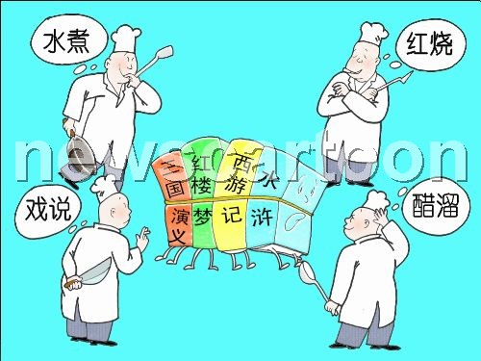

The picture gives us a view of a popular phenomenon: the adaptation of the classics. Some classical literary works, such as our four great classics i.e. A Dream of Red Mansions, Journey to the West, The Romance of the Three Kingdoms and Heroes of the Marshes, are all adapted to cater to some readers’ tastes. The traditional characters become so strange and the plots are totally different. It is so ridiculous that the precious literary treasures are allowed to be ruined so much.

As we all know, the classical literature is the representation of the outstanding art of our nation. Some familiar characters such as Monkey King express the good wishes of our common people. From them, we learn many good virtues such as honesty, bravery, justice etc. However, in those adapted works named “Bantering\*\*\*”or “Reboiling\*\*\*”, all plots are changed and all characters become somewhat watered clown. Some readers interested in reading burlesque works have high praise for them. But they never think of the negative effects of such adaptations on the average reader, especially to children. Children are the future of the nation. They always believe that what is in the books is the truth. Those adapted works will affect their outlook on life.

Therefore, some measures should be taken to restrict these adaptations. The real classics should be presented on the bookshelves to lead people to appreciate the real art.

13.

Study the two pictures above carefully and write an essay entitled “On Education of China” In the essay, you should (1) describe the pictures (2) interpret their meaning (3) give your opinion about the phenomenon .You should write about 200 words.

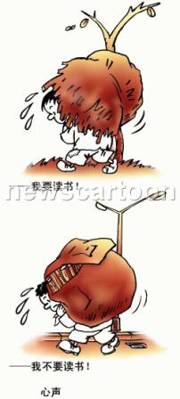

The two pictures look so similar at one glance, but they are totally different. In the first picture, a peasant boy, carrying a heavy bundle of rice straw is out of breath under the great pressure. His hope is to have a school to attend. In the second picture, a student is on his way home from school, a heavy bag of books on his back. What he wishes is that he didn’t have to go to school any more. How can the two boys at the same age have such different ideas about attending school?

The two pictures show some problems in the present education system in China. In the poor countryside, especially in some western parts of China, the education is also poor. There are no buildings for classrooms, let alone good teachers. Children there cannot have regular education. They are sometimes forced to leave their studies because their families cannot afford the necessary fees. However, the situation is totally different in the cities. Almost all the children in the cities can have regular education. They can enjoy the bright classrooms and adequate facilities. But they have their own problems. What they face is the endless homework, which puts so much pressure on them that some students don’t want to continue their studies.

Given the problems above, our government has taken some measures. “The Hope Project” has been in operation to ensure that children in the poor areas can achieve education. Some strategies have also been put into force to reduce the pressure on the students. Teachers are asked not to give too much homework. Emphasis should be put on the improvement of the quality of the students. However, there is a long way to go in the improvement of our education conditions. The whole society should be mobilized to make some contributions to our education.