9.

[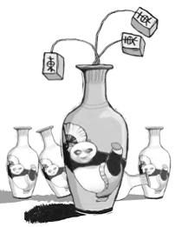](http://edu.sina.com.cn/kaoyan/2010-12-28/1225280386_6.shtml#page_pic)

In the picture, we can see that there are some vases made of china, which are typical products in China since ancient time. An image of a panda playing Kung Fu① is carved on the surface of the vases, in which both Panda and Kung Fu are the symbols of Chinese elements. Besides, the Chinese mahjong which is growing out of a vase is also a typical Chinese element。

　　It is obvious that the main purpose of the picture is to reflect the phenomenon of “China fever”， referring to a foreign passion and enthusiasm② on Chinese elements, especially culture. There are reasons accounting for the growing interest in Chinese elements. For one thing, for the past decades, China has made conspicuous progress in all fields such as economy, science and technology, and comprehensive strength of China has been enhanced greatly. For another, due to the progress, China presents a new image to the world and is becoming increasingly attractive and appealing③  to the whole world. Nearly every day news stories are reported and broadcasted④  about what is going on in and around China. And By 2010, there are 72 Confucius Institutes in 26 European countries established to spread Chinese language and culture⑤。

　　Toward this kind of “China craze”， we should hold a right attitude. On the one hand, we should take pride in the “China craze” by foreigners, which originates from the increasing prestige of China. On the other hand, it is the responsibility of each Chinese citizen to popularize and promote excellent traditional Chinese culture and guard a favorable image of our motherland。

10.

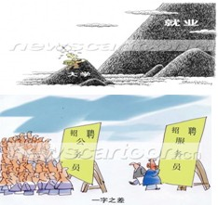

As is shown in the first picture , on a mountain of university tiredly climbs a college student, almost finishing his journey in the university, and awkwardly and surprisingly finding that he has to climb another much higher mountain---hunting a job, but as is shown below, in front of a post board for recruiting government officials stand an ocean of people, with only one in front of the board for hiring waiter. There has been a heated discussion about these pictures recently in the newspaper. Simple as the pictures are, they do demonstrate certain thought-provoking social phenomenon.

The pictures tell us the issue of hunting jobs for college students is increasingly and seriously important in current days. What’s more , individuals, organizations and even the whole society have been attaching due attention to this issue. On one hand, when facing the pressure of finding a job, students are struggling painfully. The burden can cause not only depression but also anxiety and such problems as isolation and solitude. One’s thought , creative thinking and exploration spirit, therefore, have been stifled by pursing measurable high scores and various certificates when confronting this harsh reality. On the other hand , that college students fail to change the conventional view on jobs and to adapt their goals to the reality deepens this problem. Were there no prompt and proper solution to this problem, never would we taste the happiness of the harmonious society.

What should be done to reverse this situation ? For one thing ,instead of just earning their degrees and high exam scores ,college students are expected to cultivate their potentials such as creation, imagination and coordination . Such qualities , though cannot be measured by their college certificates, really matter in their prospective career. For another thing , the educational institutions are supposed to integrate more practical training in their programs so that more competent college graduates can be produced for our society. Above all ,the new awareness that all jobs are equal in dignity and that fame and excellence can be reached at any occupation should be promoted in the whole society .

11.

Study the picture above carefully and write an essay entitled “After Graduation” In the essay, you should (1)describe the picture (2)interpret its meaning (3)give your opinion about the phenomenon. You should write about 200 words

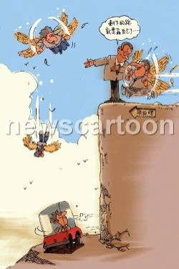

Graduation is an important event for all of us. It is the divide between school and a full-time working life. After graduation, we are no longer students protected by parents and teachers, but a member of the real society. Let’s look at the picture first. A graduate is told by his teacher, “You must depend on yourself during your life journey after graduation…” He finds that some former graduates fly high into the sky while some experience a drastic fall.

The picture tells us a principle. Graduation is not the end of your education, but the beginning of your real journey. At school, we may find we are no different from our classmates. However, there will be a great gap between us after graduation. Some may try their best to improve themselves and become the mainstay of our ear era? While some are indulged in creature comforts and give up their initial ideals.

Therefore, we should remember that graduation is the beginning of our real life journey. If you want to be a person useful to society, you should make all efforts to learn as much as possible from others and improve yourself. In this way, you may fly high in the sky.